Lab 4: The Cell Cycle (Part Two – At Home)
- Students will identify the stages of the cell cycle and calculate the approximate time spent in each.
Module Objectives (MO):
Explain mitosis and the mechanism of cell division including the behavior of chromosomes
Lab Objectives:
- Identify the stages of mitosis
- Calculate the amount of time cells spend in each stage of the cell cycle

Instructions
Part 2: Data Tables & Illustrating the Time Spent in Each Cell Cycle Stage
Now that you are familiar with the different stages of the cell cycle, we will use images of garlic roots to estimate the length of time spent in each phase. You will record your data in the provided worksheet.

Complete the table below using the slides contained the virtual lab:
 | Slide 1 | Slide 2 | Total Cells Observed in each Stage: | Time Spent (in minutes) | Percentage of time spent
Total Cell Count: |  |  |  | _____ | _____
Prophase Count:
Metaphase Count:
Anaphase Count:
Telophase Count:
Interphase Count:

- The first two data columns should contain your observations and cell counts from the two slides of garlic roots.
- Complete the “Total Cells Observed” column of the table by adding together the number of cells observed in each stage (first image + second image).
Continue by viewing the images below.
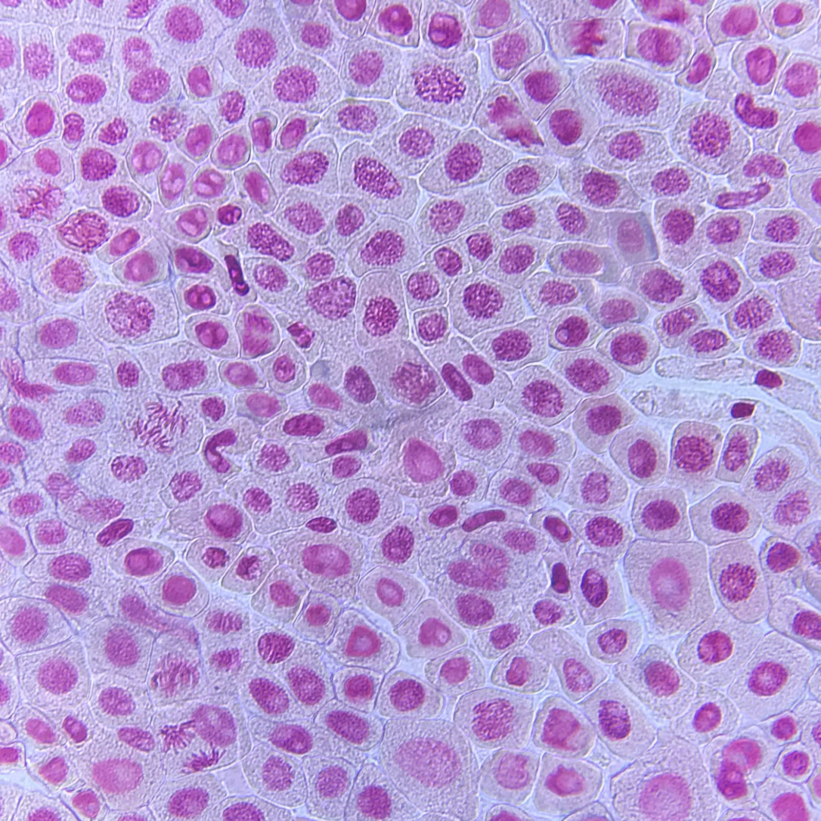
The first step is to estimate the total number of cells within the microscope image. Do this by counting across the top, then down one side and then multiply the two numbers to get at total number of cells in the field of view. These numbers should be recorded in your data table of your worksheet.
Approximately how many cells are in the slide image?
How many cells appear to clearly be in prophase?
How many cells appear to clearly be in metaphase?
How many cells appear to clearly be in anaphase?
How many cells appear to clearly be in telophase?
To get a more accurate estimate, here is another image showing another sample of garlic root cells.
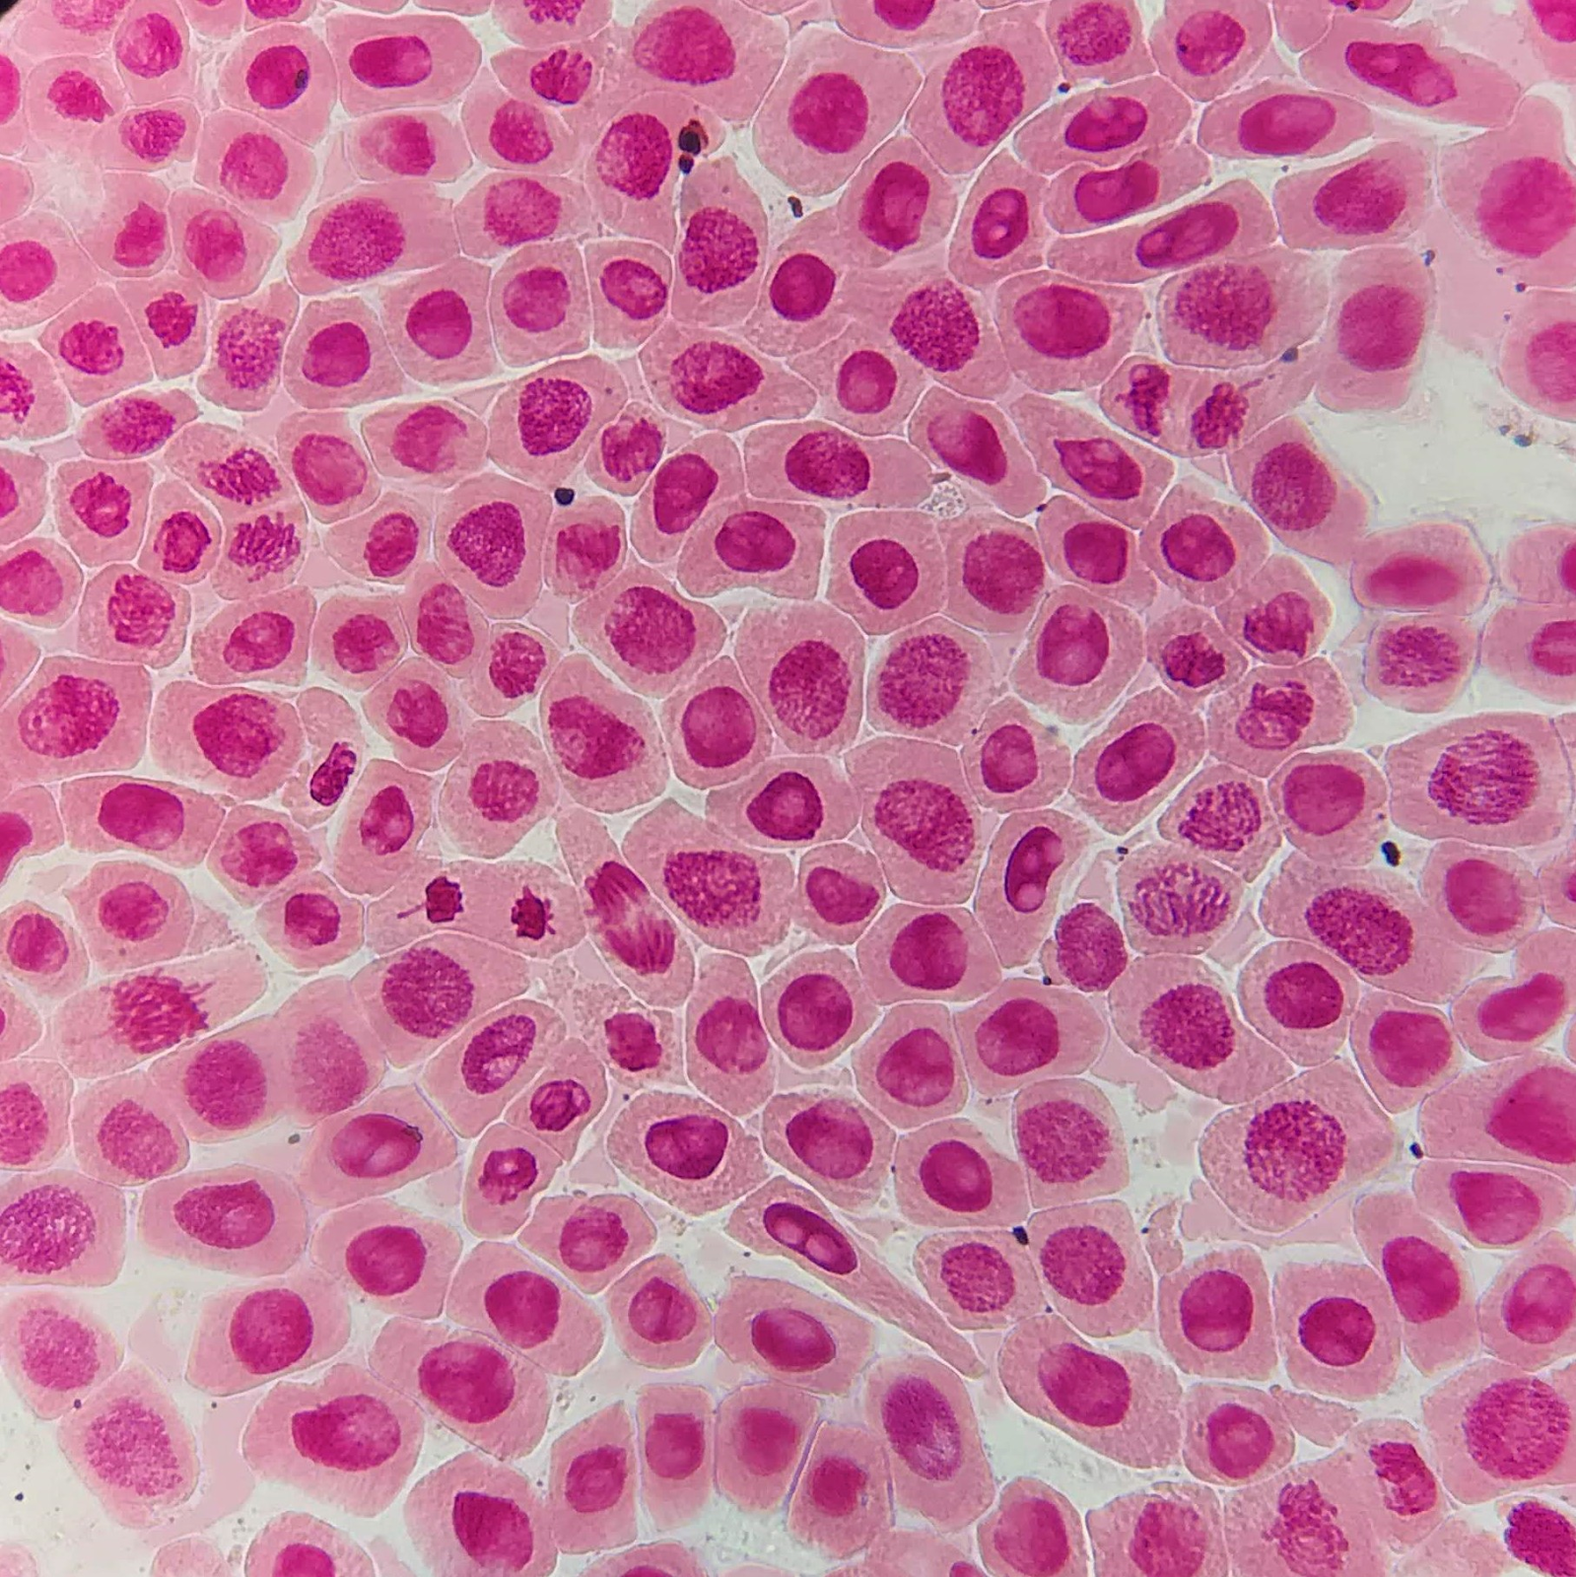
Approximately how many cells are in the slide image?
How many cells appear to clearly be in prophase?
How many cells appear to clearly be in metaphase?
How many cells appear to clearly be in anaphase?
How many cells appear to clearly be in telophase?
How many cells would be in interphase? Hint: You do not need to count these. Cells not determined to be in one of the mitosis stages would be considered in interphase. This can be calculated by subtracting all of the mitosis stage counts from the total cells present in the slide image.
3. You can assume that the number of cells in a stage is an indication of the time spent in that stage. Using this information, the time spent in a mitosis stage and in interphase can be calculated if the total time for mitosis is known. Garlic cells require 12 hours (720 minutes) to complete a cell cycle (from interphase to interphase). This information will be used to calculate the time required for each phase of the cell cycle.
Here is the formula to determine the time spent in each stage:

Time spent in a stage = (Number of cells observed in the stage/Total number of cells) x 720 minutes.
Use this formula to calculate the Time spent column of the table.
4. Now that you know approximately how many minutes were spent in each stage, that information will be used to calculate the percentage of time spent in each stage of the cell cycle. The formula to determine the percentage of time spent in each stage, and complete the last column of the data table:
(Total time spent in stage/total time)*100 = % of time
Remember that the total time for garlic cells is 720 minutes.
5. Use your information from the garlic slides to create a pie chart that illustrates the percentage of time spent in each cell cycle stage.
This video explains how to create a pie chart in excel: https://www.youtube.com/watch?v=fnE-Yq771nM
6. Submit this as a pdf file in blackboard.

